### Frontend: (developed by node and react.js)

1. Open the terminal and change the directory to “Youtube-react-app-master”.

cd Youtube-react-app-master

1. Install the dependencies using npm install
2. Start the server using npm start
3. The front end will be host on localhost:3000

### Backend:(developed by Spring boot)

1. Unzip the cis550-master.zip file.
2. For simplicity, please download an IntelliJ Idea IDE.
3. Drag the file “cis550-master” to the workspace.
4. Wait for Maven to download the dependencies. It might take several minutes.
5. Open the folder src/main/java.

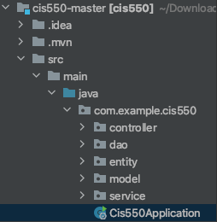

1. Then open a file named Cis550Application.
2. Click a green button next to the class name and the backend server will start.